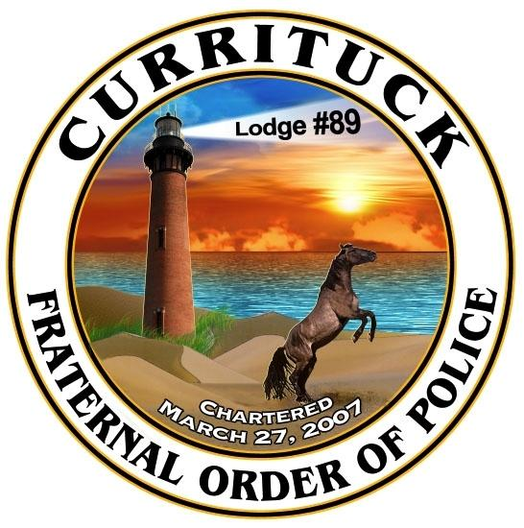
28th Annual Christmas Parade 2021 Entry Form
“A Christmas Fantasy ”
Sponsored by NC Cooperative Extension and Currituck Fraternal Order of Police Lodge #89
Friday, December 3, 2021 at 7:00 pm
(If inclement weather occurs, the event will not be rescheduled.)

Parade Route: The parade route will begin on College Way in front of the COA building. The parade will travel down Maple Parkway then turn on to Community Way and drive through the YMCA and N.C. Cooperative Extension Parking lots. Once at Aviation Parkway, the parade will continue to the Barco Way intersection where parade participants can leave or stage in that area for pick up.

Complete the form below, sign and return it to: NC Cooperative Extension Currituck County Center Attn: Sheila Gregory 120 Community Way Barco, NC 27917 or via email: sheila_gregory@ncsu.edu no later than November 27, 2021.
Please check one:

_____ I wish for my entry to be judged.
*Please note that there is a $20 entry fee for judging. Entry fee must be paid with registration. NO REFUNDS will be given.

_____ I DO NOT wish for my entry to be judged.
*No Fee

Please check your entry below:
Antique Car (no.) _____
Band _____
Scouts _____
Horses (no.) _____
Motorcycle (no.) _____
Business _____

PLEASE NOTE: No tractor-trailers are allowed to participate due to the parade route.
LIVE SANTAS ARE NOT ALLOWED ON ANY FLOAT.

If entry is not listed above, please list here: ______________________________________________________________

Please Circle One: Individual Entry Company Organization Group
Name of Entry: ___________________________________________________________________________________
Contact Name: ___________________________ Address: ______________________________________________
Phone #: ________________________________ Email: _______________________________________________
Will your group be (Please check): ____Walking Only ____Float Only ____Walking and Float ____Have Animals

If you have questions please contact Sheila Gregory at 252-232-2261, fax 252-453-2782, or email sheila_gregory@ncsu.edu or contact Lt. Kevin McCord at 252-207-4653 or email 209@currituckcountync.gov.
For Office Use Only

Entry Number_________

Paid Fee_________

I agree not to be a party of any claim, action, or suit against the County of Currituck,
NC Cooperative Extension, Currituck Sheriff's Dept. or Currituck Fraternal Order
of Police Lodge #89.

Signature ____________________________________ Date _____________________

